import tensorflow as tf

from tensorflow.keras.datasets import fashion_mnist

from tensorflow.keras.layers import Conv2D, Dropout, MaxPooling2D, Flatten, Dense

from tensorflow.keras.utils import to_categorical

# Helper libraries

import numpy as np

import matplotlib.pyplot as plt

(train_images, train_labels), (test_images, test_labels) = fashion_mnist.load_data()

train_images = train_images.astype('float32') / 255

test_images = test_images.astype('float32') / 255

train_images = train_images.reshape(train_images.shape[0], 28, 28, 1)

test_images = test_images.reshape(test_images.shape[0], 28, 28, 1)

train_labels = tf.keras.utils.to_categorical(train_labels, 10)

test_labels = tf.keras.utils.to_categorical(test_labels, 10)

**MODELO WITH FLATTEN, DROPOUT**

model = tf.keras.Sequential()

# Must define the input shape in the first layer of the neural network

model.add(Conv2D(filters=64, kernel_size=2, padding='same',

activation='relu', input_shape=(28,28,1)))

model.add(MaxPooling2D(pool_size=2))

model.add(Dropout(0.3))

model.add(Conv2D(filters=32, kernel_size=2, padding='same', activation='relu'))

model.add(MaxPooling2D(pool_size=2))

model.add(Dropout(0.3))

model.add(Flatten())

model.add(Dense(256, activation='relu'))

model.add(Dropout(0.5))

model.add(Dense(10, activation='softmax'))

model.summary()

=======================================================

**COMPILE**

model.compile(loss='categorical_crossentropy',

             optimizer='rmsprop',

             metrics=['accuracy'])

**FIT**

history=model.fit(train_images,

         train_labels,

         batch_size=64,

         epochs=10)

Epoch 1/10

938/938 [==============================] - 10s 10ms/step - loss: 0.3181 - accuracy: 0.8900

Epoch 2/10

938/938 [==============================] - 9s 10ms/step - loss: 0.3196 - accuracy: 0.8891

Epoch 3/10

938/938 [==============================] - 9s 10ms/step - loss: 0.3254 - accuracy: 0.8876

Epoch 4/10

938/938 [==============================] - 9s 10ms/step - loss: 0.3221 - accuracy: 0.8889

Epoch 5/10

938/938 [==============================] - 9s 9ms/step - loss: 0.3214 - accuracy: 0.8909

Epoch 6/10

938/938 [==============================] - 8s 9ms/step - loss: 0.3243 - accuracy: 0.8885

Epoch 7/10

938/938 [==============================] - 8s 9ms/step - loss: 0.3300 - accuracy: 0.8882

Epoch 8/10

938/938 [==============================] - 9s 9ms/step - loss: 0.3292 - accuracy: 0.8874

Epoch 9/10

938/938 [==============================] - 9s 9ms/step - loss: 0.3306 - accuracy: 0.8877

Epoch 10/10

938/938 [==============================] - 9s 9ms/step - loss: 0.3328 - accuracy: 0.8875

**SCORE**

score = model.evaluate(test_images, test_labels, verbose=0)

print(score)

LOSS ACCURACY

[0.2901, 0.902]

import pandas as pd

pd.DataFrame(history.history).plot(figsize=(10,8));

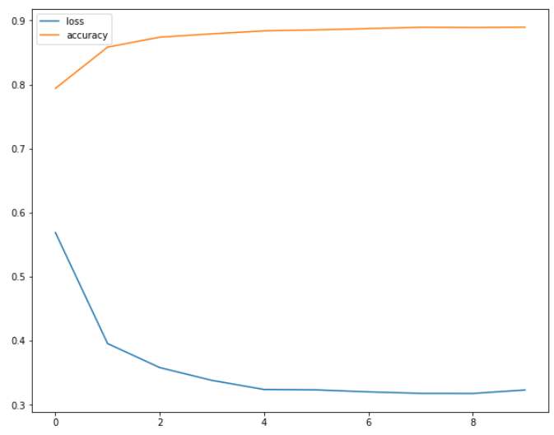

===================================

**MODELO WITH REGULATORS**

<https://keras.io/api/layers/regularizers/>

Regularizers allow to apply penalties on layer parameters or layer activity during optimization.

These penalties are summed into the loss function that the network optimizes.

from tensorflow.keras import regularizers

model_optimizer = tf.keras.models.Sequential([

       tf.keras.layers.Flatten(input_shape= (28, 28, 1)),

       tf.keras.layers.Dense(256,

kernel_regularizer = regularizers.l2(1e-5), activation = "relu"),

       tf.keras.layers.Dropout(0.2),

model.add(Flatten()),

      tf.keras.layers.Dense(128,

kernel_regularizer= regularizers.l2(1e-5),activation = "relu"),

tf.keras.layers.Dropout(0.2),

       tf.keras.layers.Dense(10, activation = "softmax")

])

model_optimizer.summary()

**COMPILE**

**FIT**

**SCORE**

**GRAPH**

**[0.27475, 0.90530002]**

Loss menor, 0.27 reduciendose

Accuracy aumento 0.905

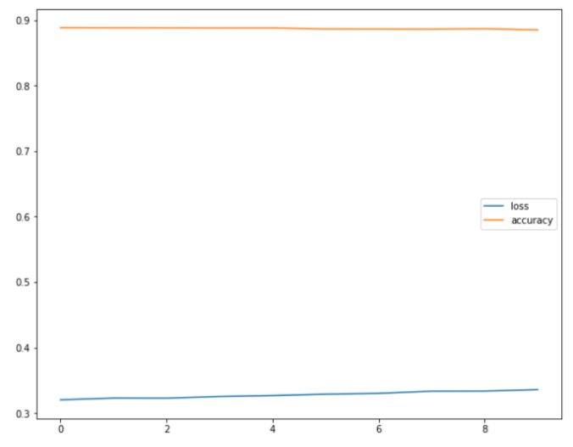

**MODELO CON LEARNING RATE**

**COMPILE PREVIO**

model.compile(loss='categorical_crossentropy',

             optimizer='rmsprop',

             metrics=['accuracy'])

**COMPILE NUEVO**

**LR** = hp.Choice('learning_rate', values = [1e-2, 1e-3, 1e-4])

model.compile(loss='categorical_crossentropy',

             optimizer = keras.optimizers.Adam(learning_rate=LR),

metrics=['accuracy'])

from tensorflow import keras

opt = keras.optimizers.Adam(learning_rate=0.01)

model.compile(loss='categorical_crossentropy',

             optimizer = opt,

             metrics=['accuracy'])

==================================

**CALLBACKS DESPUES DE COMPILAR**

**COMPILE**

**FIT**

early = tf.keras.callbacks.EarlyStopping(monitor='accuracy',patience=1)

model.fit(train_images,

         train_labels,

         batch_size=64,

        callbacks=[early],

         epochs=10)

from tensorflow.keras.callbacks import ModelCheckpoint

model.compile(optimizer = "adam",

loss = "categorical_crossentropy",

metrics = ["accuracy"])

# Creamos unos checkpoint de nuestros modelos con TensorFlow, verbose: mostrar mas información

checkpoint_path = "model_checpoints/checkpoint"

checkpoint_weighs= ModelCheckpoint(

    filepath = checkpoint_path,

    frecuency = "epoch",

    save_weights_only = True,

    verbose = 1

)

# Entrenamos el modelo, y almacenamos en cada steps los pesos del moedelo.

history_weight = model_weight.fit(

    train_generator,

    epochs = 20,

    callbacks = [checkpoint_weighs],

    validation_data = validation_generator

)

model_weight.save_weights("model_manul/my_model")

fit

checkpoint = tf.keras.callbacks.ModelCheckpoint(filepath='mi_primer_red_conv.hdf5',

                                verbose=1,

                                monitor='accuracy',

                                save_best_only=True)

**SCORE**

[0.3124, 0.903]

**TRAINING CALLBACK, SI LLEGO A 95%**

from tensorflow.keras.callbacks import Callback

class **TrainingCallback**(Callback):

  def on_epoch_end(self, epoch, logs = {}):

    if logs.get("accuracy") > 0.95:

      print("Lo logramos, modelo llego a 95%, detenemos el entrenamiento")

      self.model.stop_training = True

callback = **TrainingCallback**()

history_callback = model_callback.fit(

    train_generator,

    epochs = 20,

    callbacks = [callback],

    validation_data = validation_generator

def get_model():

  model = tf.keras.models.Sequential([

          tf.keras.layers.Conv2D(75, (3,3),

activation = "relu", input_shape= (28, 28, 1)),

          tf.keras.layers.MaxPool2D((2,2)),

          tf.keras.layers.Flatten(),

          tf.keras.layers.Dense(256,

kernel_regularizer = regularizers.l2(1e-5), activation = "relu"),

 tf.keras.layers.Dropout(0.2),

          tf.keras.layers.Dense(128,

kernel_regularizer= regularizers.l2(1e-5),activation = "relu"),

 tf.keras.layers.Dropout(0.2),

          tf.keras.layers.Dense(len(classes), activation = "softmax")

  ])

  return model

model_early = get_model()

model_early.summary()

model_early.compile(optimizer= "adam",

loss = "categorical_crossentropy", metrics = ["accuracy"])

Model: "sequential_4"

_________________________________________________________________

Layer (type) Output Shape Param #

=================================================================

conv2d_2 (Conv2D) (None, 26, 26, 75) 750

_________________________________________________________________

max_pooling2d_2 (MaxPooling2 (None, 13, 13, 75) 0

_________________________________________________________________

flatten_4 (Flatten) (None, 12675) 0

_________________________________________________________________

dense_12 (Dense) (None, 256) 3245056

_________________________________________________________________

dropout_6 (Dropout) (None, 256) 0

_________________________________________________________________

dense_13 (Dense) (None, 128) 32896

_________________________________________________________________

dropout_7 (Dropout) (None, 128) 0

_________________________________________________________________

dense_14 (Dense) (None, 24) 3096

=================================================================

Total params: 3,281,798

Trainable params: 3,281,798

Non-trainable params: 0

_________________________________________________________________

CodeText

COMPILE

FIT

SCORE

EARLY STOPPING

callback_early = tf.keras.callbacks.EarlyStopping(monitor = "loss",

patience=3, mode = "auto")

history_early = model_early.fit(

    train_generator,

    epochs= 20,

    callbacks = [callback_early],

    validation_data = validation_generator

)